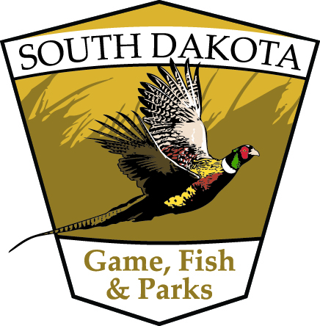
Hunting for Sustainability
Post-Program Participant Survey

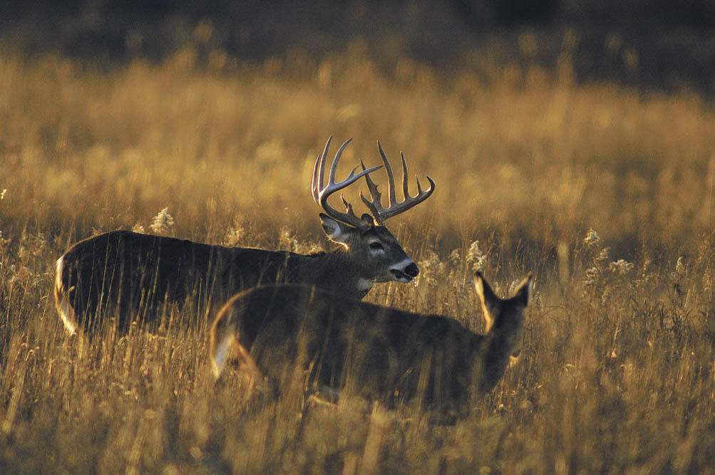

Introduction and Instructions
Thank you for taking part in the Hunting for Sustainability program. We’d like to know more about your experience and your feelings about hunting. Your responses will help us improve the Hunting for Sustainability program—thanks in advance for your participation.
Please enter your participant number below so that we can match your answers to the two surveys. All of your responses will be kept completely confidential; no data collected will ever be associated with your name. Questionnaires will be analyzed by Responsive Management, a trusted independent research firm specializing in natural resource and outdoor recreation issues.
Date Participant #
Assessment of Hunting for Sustainability Program
 | Poor |  | Neutral |  | Excellent
Overall, how would you rate the entire Hunting for Sustainability program? | 1 | 2 | 3 | 4 | 5

 | Extremely negative |  | Neutral |  | Extremely positive | Not applicable
Overall, was your experience with the instructional aspects of the Hunting for Sustainability program positive or negative? | 1 | 2 | 3 | 4 | 5 | n/a
Overall, was your experience actually hunting during the Hunting for Sustainability program positive or negative? | 1 | 2 | 3 | 4 | 5 | n/a

How would you rate each of the individual [sessions/events] of the Hunting for Sustainability program?
 | Poor |  | Neutral |  | Excellent
[Session #1/name] | 1 | 2 | 3 | 4 | 5
[Session #2/name] | 1 | 2 | 3 | 4 | 5
[Session #3/name] | 1 | 2 | 3 | 4 | 5
[Session #4/name] | 1 | 2 | 3 | 4 | 5
[Session #5/name] | 1 | 2 | 3 | 4 | 5

Overall, how would you rate each of the following aspects of the Hunting for Sustainability program?
 | Poor |  | Neutral |  | Excellent | Not applicable
Quality of information/instruction | 1 | 2 | 3 | 4 | 5 | n/a
Amount of information/instruction | 1 | 2 | 3 | 4 | 5 | n/a
Organization of information/instruction | 1 | 2 | 3 | 4 | 5 | n/a
Usefulness and practicality of information/ instruction | 1 | 2 | 3 | 4 | 5 | n/a
Hands-on demonstrations | 1 | 2 | 3 | 4 | 5 | n/a
Instructor’s knowledge | 1 | 2 | 3 | 4 | 5 | n/a
Instructor’s experience | 1 | 2 | 3 | 4 | 5 | n/a
Instructor’s ability to explain | 1 | 2 | 3 | 4 | 5 | n/a
Instructor’s ability to demonstrate | 1 | 2 | 3 | 4 | 5 | n/a
How effective was the Hunting for Sustainability program in accomplishing each of the following?
 | Not at all effective |  | Somewhat effective |  | Extremely effective | Not applicable
Creating enjoyable social experiences | 1 | 2 | 3 | 4 | 5 | n/a
Providing opportunities to meet and connect with fellow hunters | 1 | 2 | 3 | 4 | 5 | n/a
Increasing interest in hunting | 1 | 2 | 3 | 4 | 5 | n/a
Increasing learning through mentoring | 1 | 2 | 3 | 4 | 5 | n/a
Providing you with the necessary skills and knowledge to hunt | 1 | 2 | 3 | 4 | 5 | n/a
Increasing the likelihood that you will hunt in the future | 1 | 2 | 3 | 4 | 5 | n/a
Encouraging you to invite others to hunt | 1 | 2 | 3 | 4 | 5 | n/a
Preparing you to hunt on your own | 1 | 2 | 3 | 4 | 5 | n/a

- What species of game are you interested in hunting? Please list:

- Would you say the length of the program was…?
Too long
About right
Too short

- Would you say the number of participants in the program was…?
Too many
About right
Too few

- Would you say the skill level of the program was…?
Too advanced
About right
Too novice

Hunting Skills
How confident do you feel about your skills or knowledge in each of the following areas?
 | Not at all confident |  | Somewhat confident |  | Extremely confident | Not applicable
Firearm safety | 1 | 2 | 3 | 4 | 5 | n/a
Shooting skills | 1 | 2 | 3 | 4 | 5 | n/a
Hunting license requirements | 1 | 2 | 3 | 4 | 5 | n/a
Hunting seasons and regulations | 1 | 2 | 3 | 4 | 5 | n/a
Identifying places to hunt (access) | 1 | 2 | 3 | 4 | 5 | n/a
Scouting and choosing hunting spots | 1 | 2 | 3 | 4 | 5 | n/a
Ethical shot placement | 1 | 2 | 3 | 4 | 5 | n/a
Field recovery of game | 1 | 2 | 3 | 4 | 5 | n/a
Field dressing | 1 | 2 | 3 | 4 | 5 | n/a
Butchering and preservation | 1 | 2 | 3 | 4 | 5 | n/a
Cooking harvested meat | 1 | 2 | 3 | 4 | 5 | n/a

- Which of the following best describes your experience obtaining a hunting license for the current season? (please select only one answer)
I purchased a hunting license for the current season before learning about this program
I purchased a hunting license for the current season in order to participate in this program
I received a hunting license for the current season as part of the registration for this program
I have not yet obtained a hunting license for the current season
 | Not at all likely |  | Somewhat likely |  | Extremely likely | Not applicable
After this program, how likely are you to go hunting during the current season? | 1 | 2 | 3 | 4 | 5 | n/a

(Please select “n/a” if the current season has already ended.)

Is there anything else you’d like us to know about how this program could be improved? If so, please include your comments here.

Thank you for participating in our program, and for taking the time to complete this questionnaire.

