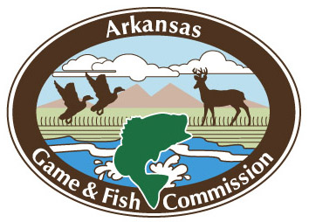
[Name of Fishing Program]
Post-Program Participant Survey

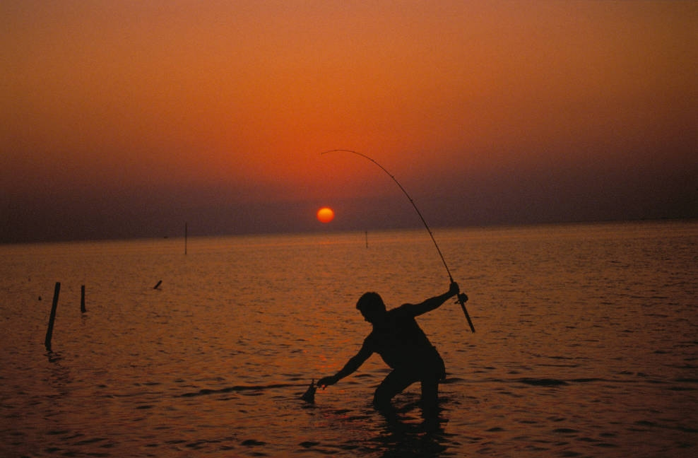

Introduction and Instructions
Thank you for taking part in the [insert program name] program. We’d like to know more about your experience and your feelings about fishing. Your responses will help us improve the [insert program name]—thanks in advance for your participation.
Please enter your participant number below so that we can match your answers to the two surveys. All of your responses will be kept completely confidential; no data collected will ever be associated with your name. Questionnaires will be analyzed by Responsive Management, a trusted independent research firm specializing in natural resource and outdoor recreation issues.
Date Participant #
Assessment of [insert program name]
 | Poor |  | Neutral |  | Excellent
Overall, how would you rate the entire [insert program name] program? | 1 | 2 | 3 | 4 | 5

 | Extremely negative |  | Neutral |  | Extremely positive | Not applicable
Overall, was your experience with the instructional aspects of the [insert program name] program positive or negative? | 1 | 2 | 3 | 4 | 5 | n/a
Overall, was your experience actually fishing during the [insert program name] program positive or negative? | 1 | 2 | 3 | 4 | 5 | n/a

How would you rate each of the individual [sessions/events] of the [insert program name]?
 | Poor |  | Neutral |  | Excellent
[Session #1/name] | 1 | 2 | 3 | 4 | 5
[Session #2/name] | 1 | 2 | 3 | 4 | 5
[Session #3/name] | 1 | 2 | 3 | 4 | 5
[Session #4/name] | 1 | 2 | 3 | 4 | 5
[Session #5/name] | 1 | 2 | 3 | 4 | 5

Overall, how would you rate each of the following aspects of the [insert program name]?
 | Poor |  | Neutral |  | Excellent | Not applicable
Quality of information/instruction | 1 | 2 | 3 | 4 | 5 | n/a
Amount of information/instruction | 1 | 2 | 3 | 4 | 5 | n/a
Organization of information/instruction | 1 | 2 | 3 | 4 | 5 | n/a
Usefulness and practicality of information/ instruction | 1 | 2 | 3 | 4 | 5 | n/a
Hands-on demonstrations | 1 | 2 | 3 | 4 | 5 | n/a
Instructor’s knowledge | 1 | 2 | 3 | 4 | 5 | n/a
Instructor’s experience | 1 | 2 | 3 | 4 | 5 | n/a
Instructor’s ability to explain | 1 | 2 | 3 | 4 | 5 | n/a
Instructor’s ability to demonstrate | 1 | 2 | 3 | 4 | 5 | n/a
How effective was the [insert program name] in accomplishing each of the following?
 | Not at all effective |  | Somewhat effective |  | Extremely effective | Not applicable
Creating enjoyable social experiences | 1 | 2 | 3 | 4 | 5 | n/a
Providing opportunities to meet and connect with fellow anglers | 1 | 2 | 3 | 4 | 5 | n/a
Increasing interest in fishing | 1 | 2 | 3 | 4 | 5 | n/a
Increasing learning through mentoring | 1 | 2 | 3 | 4 | 5 | n/a
Providing you with the necessary skills and knowledge to fish | 1 | 2 | 3 | 4 | 5 | n/a
Increasing the likelihood that you will fish in the future | 1 | 2 | 3 | 4 | 5 | n/a
Encouraging you to invite others to fish | 1 | 2 | 3 | 4 | 5 | n/a
Preparing you to fish on your own | 1 | 2 | 3 | 4 | 5 | n/a

- What species of fish are you interested in fishing? Please list:

- Would you say the length of the program was…?
Too long
About right
Too short

- Would you say the number of participants in the program was…?
Too many
About right
Too few

- Would you say the skill level of the program was…?
Too advanced
About right
Too novice

Fishing Skills
How confident do you feel about your skills or knowledge in each of the following areas?
 | Not at all confident |  | Somewhat confident |  | Extremely confident | Not applicable
Using appropriate bait and lure to catch fish | 1 | 2 | 3 | 4 | 5 | n/a
Fishing technique (e.g., casting, reeling) | 1 | 2 | 3 | 4 | 5 | n/a
Fishing license requirements | 1 | 2 | 3 | 4 | 5 | n/a
Fishing seasons and regulations | 1 | 2 | 3 | 4 | 5 | n/a
Identifying places to fish (access) | 1 | 2 | 3 | 4 | 5 | n/a
Choosing the right spot on the water to catch fish | 1 | 2 | 3 | 4 | 5 | n/a
Cleaning fish | 1 | 2 | 3 | 4 | 5 | n/a
Preparation and cooking of fish | 1 | 2 | 3 | 4 | 5 | n/a

- Which of the following best describes your experience obtaining a fishing license for the current season? (please select only one answer)
I purchased a fishing license for the current season before learning about this program
I purchased a fishing license for the current season in order to participate in this program
I received a fishing license for the current season as part of the registration for this program
I have not yet obtained a fishing license for the current season
 | Not at all likely |  | Somewhat likely |  | Extremely likely | Not applicable
After this program, how likely are you to go fishing during the current season? | 1 | 2 | 3 | 4 | 5 | n/a

(Please select “n/a” if the current season has already ended.)

Is there anything else you’d like us to know about how this program could be improved? If so, please include your comments here.

Thank you for participating in our program, and for taking the time to complete this questionnaire.

