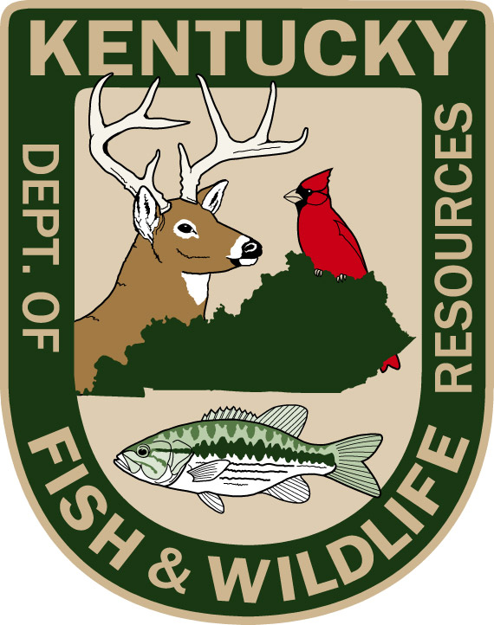
[Name of Fishing Program]
Instructor Questionnaire

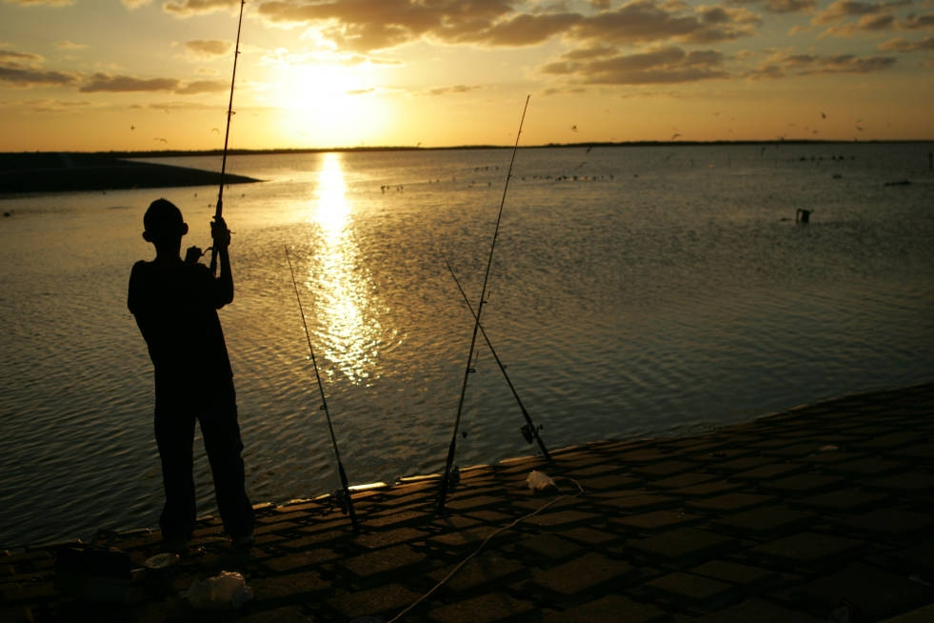

Introduction
The Kentucky Department of Fish and Wildlife Resources is working with Responsive Management, a professional survey research firm, to evaluate participant, instructor, and mentor experiences with the [PROGRAM NAME].

As an instructor, we would like to know your opinions on the effectiveness of the program. Your responses will help improve the [PROGRAM NAME]—thanks in advance for your input.

Program Role and Goals
- Please describe your role as an instructor for the [PROGRAM NAME]. For example, did you teach program sessions, assist in organizing an event, lead a fishing outing, etc.?

- Please describe your goals as an instructor for the [PROGRAM NAME] in terms of what you hoped to teach participants or accomplish in general.

Overall Program Impressions
- Based on your experience with the program, what do you see as the most important strengths of the [PROGRAM NAME]?

- Based on your experience with the program, what do you see as the most important challenges that the [PROGRAM NAME] faces?

- Which aspects or elements of the program do you think were the most successful?
(For example, a certain session or event, an instructional topic, or an area of focus in the program.)

  - Why?

- Which aspects or elements of the program do you think were the least successful?
(For example, a certain session or event, an instructional topic, or an area of focus in the program.)

  - Why?

Opinions on Program Structure and Content
For the next three questions, please think about your observations of program participants and the ability of the program to impart information and instruction effectively.
- Would you say the length of the program was too long, about right, or too short?

- Would you say the number of participants in the program was too many, about right, or too few?

- Would you say the skill level of the program was too advanced, about right, or too novice?

Observations of Program Participants
- What observations do you have, either positive or negative, about the experiences of program participants?

- Based on your observations of program participants, what could the program do differently in the future to become more effective?

Opinions on Instructor Training and Support
- Are there any gaps or unfulfilled needs in terms of the training and instruction provided to program instructors?

  - If so, what are they?

Respondent Background and Program Goals
- How many years of experience do you have instructing or mentoring other anglers in an informal setting, such as teaching friends or family members on your own time?

- How many years of experience do you have instructing or mentoring other anglers in a formal setting, such as teaching participants in an organized program?

Additional Comments
Thank you for answering this survey. Do you have any other feedback or comments about the program based on your experience and observations of program participants?

Thank you for your involvement in our program,
and for taking the time to complete this questionnaire.

