EVENT NAME
Pre-event Questionnaire
CITY, DATE

Thank you for participating in this EVENT NAME. We have a couple of questions to ask you that will help us learn from and improve this event over time. We will also ask you several other questions at the end of the event. Your responses will be kept confidential and used for program and administrative use only. Thank you for your time and honest input.
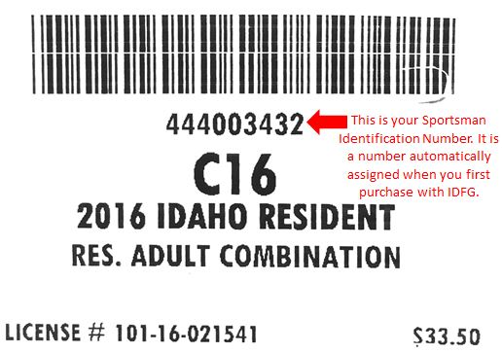
Background info

Name ________________________________

D.O.B. ___/ ____/ ____

Sportsman’s Identification Number __ __ __ __ __ __ __ __ __
Hunting Experience and Support

1. How much knowledge of these topics do you feel you have prior to the class?

TOPIC | A lot | Some | A Little | None
Turkey Biology
Turkey Habitat
Firearm selection
Firearm safety
Firearm handling
Wildlife law
Hunting ethics
Hunting techniques
How to plan a hunt

2. Please comment on whether this 2 full day schedule was appropriate and worked for your schedule or if the class could use (1) shortening or (2) rearranging of days for evening weekday classes instead of weekends.

3. Have you hunted in the past?
⃝ Yes (if yes, roughly how many times have you hunted? _________)
⃝ No

4. If you have hunted before, please check any of the following game species you have already tried hunting before this course (check all that apply).
□ Waterfowl (geese, ducks) □ Small game (rabbits, squirrels…)
□ Upland birds (pheasant, grouse, quail…) □ Predator species (bear, wolf, cougar…)
□ Big game (deer, elk, moose…) □ Other, please specify _______________
□ Wild turkey
5. Who else, if anyone, in your life hunts? Check all that apply.
⃝ Direct family [spouse, parent(s), sibling(s), children]
⃝ Extended family [aunt/uncle, cousins, in-laws]
⃝ Friend(s), co-worker(s)
⃝ Other___________________
⃝ None

6. To what degree do you think your family, friends and/or peers are supportive of hunting?
⃝ Very supportive
⃝ Supportive
⃝ Unsupportive
⃝ Very unsupportive
⃝ No opinion

7. How likely do you think it is that you will hunt in the future?
⃝ Very likely
⃝ Likely
⃝ Not likely
⃝ Very unlikely

Why or why not?

8. Please indicate if the following skills/circumstances are barriers to your participation in hunting activities. Circle appropriate number, 1 being no barrier and 5 being a significant barrier that has completely prevented you from hunting.
No barrier---------------------------------------------------Significant barrier
Understanding hunting laws and regulations | 1 | 2 | 3 | 4 | 5
Knowing where to go | 1 | 2 | 3 | 4 | 5
Knowing how to handle/dress a harvested animal | 1 | 2 | 3 | 4 | 5
Fear or lack of understanding of firearms | 1 | 2 | 3 | 4 | 5
The cost of equipment or license | 1 | 2 | 3 | 4 | 5
Having the time to hunt | 1 | 2 | 3 | 4 | 5
Having someone to go hunting with | 1 | 2 | 3 | 4 | 5

9. What would increase the likelihood of you hunting in the future?

IDFG
10. What is your general opinion of the overall performance of the IDFG in managing and protecting the state’s fish and wildlife resources?
⃝ Excellent ⃝ Good ⃝ Fair ⃝ Poor ⃝ No opinion
11. Overall, how satisfied are you with the IDFG as a state government agency in Idaho?

⃝ Very satisfied ⃝ Somewhat dissatisfied
⃝ Somewhat satisfied ⃝ Very dissatisfied
⃝ Neither satisfied nor dissatisfied ⃝ Don’t know

12. Before taking this class, how much would you say you know about the activities of IDFG?

⃝ A great deal ⃝ A moderate amount ⃝ A little ⃝ Nothing

13. Have you ever contacted an IDFG employee for information or assistance?

⃝ Yes ⃝ No

14. Have you ever volunteered your time for IDFG?

⃝ Yes ⃝ No

15. On a scale of 1-5, 1 being not likely at all and 5 being very likely, how likely are you to do the following?
(Circle appropriate number)

Pay attention to and provide input on legislation that affects hunting in Idaho | 1 | 2 | 3 | 4 | 5
Call Citizens Against Poaching or local law enforcement after witnessing something that seems illegal. | 1 | 2 | 3 | 4 | 5
Provide feedback to IDFG on hunting regulations at meetings or other venues. | 1 | 2 | 3 | 4 | 5

