Social Support: Social Support

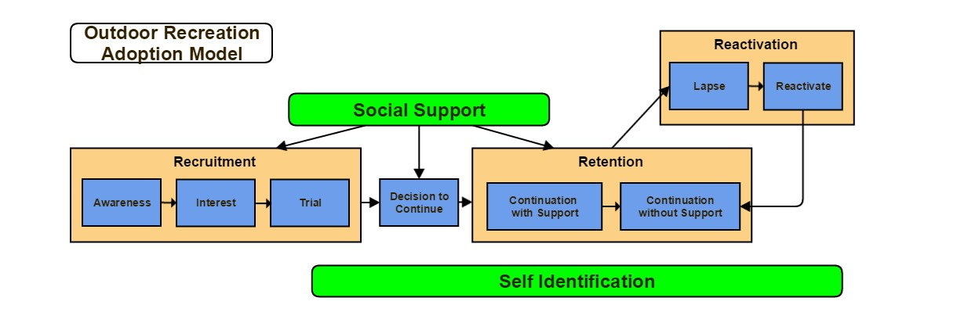

What are the opportunities in your curriculum to promote peer support?
______________________________________________________________________________________________________________________________________________________________________________________________________________________________________________________________________________________________________________________________________________________________________________________________________________________________________________________________________________________________________________________________
Are there other individuals in your agency that are already facilitating support after the class is over? List them.
______________________________________________________________________________________________________________________________________________________________________________________________________________________________________________________________________________________________________________________________________________________________________________________________________________________________________________________________________________________________________________________________
What retailers are in your target cities that you might use to promote these in-an-out of class support activities?
______________________________________________________________________________________________________________________________________________________________________________________________________________________________________________________________________________________________________________________________________________________________________________________________________________________________________________________________________________________________________________________________

What newsletters or e-newsletters exist that your agency can forward on to students?
______________________________________________________________________________________________________________________________________________________________________________________________________________________________________________________________________________________________________________________________________________________________________________________________________________________________________________________________________________________________________________________________
What eblast programs (e.g. Mailchimp) or systems does your agency already have in place that could be used to communicate with students after graduation?
______________________________________________________________________________________________________________________________________________________________________________________________________________________________________________________________________________________________________________________________________________________________________________________________________________________________________________________________________________________________________________________________

