Messaging: Attracting Attention
List some RELEVANT words and images you feel will attract the attention of your audience.
(For example: A photo of a nice piece of salmon cooking on the grill)
- _____________________________________________________________________________
- ______________________________________________________________________________
- ______________________________________________________________________________
- ______________________________________________________________________________
- ______________________________________________________________________________

List some NOT NECESSARILY RELEVANT words and images you feel will attract the attention of your audience. (For example: a Shiny Red Ford Raptor)
- _____________________________________________________________________________
- ______________________________________________________________________________
- ______________________________________________________________________________
- ______________________________________________________________________________
- ______________________________________________________________________________

List some GRAPHIC ELEMENTS you feel will attract the attention of your audience.
(For example: the word “QUIET” in big bold type.)
- _____________________________________________________________________________
- ______________________________________________________________________________
- ______________________________________________________________________________
- ______________________________________________________________________________
- ______________________________________________________________________________

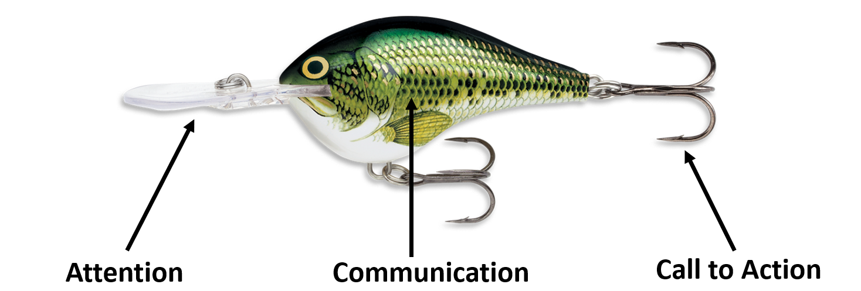
Messaging: Communication
List the 5 most important features of your program (from the participants viewpoint)
How does the participant benefit from each feature
Feature
__________________________________________________________________________________________________________________________________________________________________________
Benefit (to the participant)
____________________________________________________________________________________________________________________________________________________________

Feature
__________________________________________________________________________________________________________________________________________________________________________
Benefit (to the participant)
____________________________________________________________________________________________________________________________________________________________

Feature
__________________________________________________________________________________________________________________________________________________________________________
Benefit (to the participant)
____________________________________________________________________________________________________________________________________________________________

Feature
__________________________________________________________________________________________________________________________________________________________________________
Benefit (to the participant)
____________________________________________________________________________________________________________________________________________________________

Feature
__________________________________________________________________________________________________________________________________________________________________________
Benefit (to the participant)
____________________________________________________________________________________________________________________________________________________________
Messaging: Call to Action
What do you ultimately want prospects to do?
__________________________________________________________________________________________________________________________________________________________________________

What do you want them to do as a result of your message?
__________________________________________________________________________________________________________________________________________________________________________

List all the ways they could take your call to action.
- _____________________________________________________________________________
- ______________________________________________________________________________
- ______________________________________________________________________________
- ______________________________________________________________________________
- ______________________________________________________________________________

What are the benefits to them if they take that action?
- _____________________________________________________________________________
- ______________________________________________________________________________
- ______________________________________________________________________________
- ______________________________________________________________________________
- ______________________________________________________________________________

Messaging: Message Chain
List the steps from first message to signing up for your program
What information is needed at each step?
What is the call to action at each step?

Step 1: _________________________________________________________________________
Information Needed
- ___________________________________________________________________________
- ___________________________________________________________________________
- ___________________________________________________________________________
Call-to-action: __________________________________________________________________

Step 2: _________________________________________________________________________
Information Needed
- ___________________________________________________________________________
- ___________________________________________________________________________
- ___________________________________________________________________________
Call-to-action: __________________________________________________________________

Step 3: _________________________________________________________________________
Information Needed
- ___________________________________________________________________________
- ___________________________________________________________________________
- ___________________________________________________________________________
Call-to-action: __________________________________________________________________

Step 4: _________________________________________________________________________
Information Needed
- ___________________________________________________________________________
- ___________________________________________________________________________
- ___________________________________________________________________________
Call-to-action: __________________________________________________________________

Step 5: _________________________________________________________________________
Information Needed
- ___________________________________________________________________________
- ___________________________________________________________________________
- ___________________________________________________________________________
Call-to-action: __________________________________________________________________

