Introduction: A Personal Experience with the
Outdoor Recreation Adoption Model

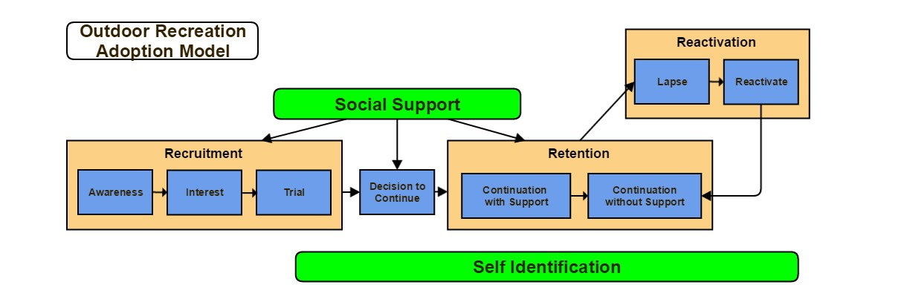

Name an activity you started since you got out of school: ___________________________________

Describe how/why you first became interested in that activity:
____________________________________________________________________________________________________________________________________________________________________________________________________________________________________________________________________________________________________________________________________________________

Describe how you first tried that activity:
____________________________________________________________________________________________________________________________________________________________________________________________________________________________________________________________________________________________________________________________________________________

Did you ultimately decide to continue with that activity or abandon it?
____________________________________________________________________________________________________________________________________________________________________________________________________________________________________________________________________________________________________________________________________________________

What factors influenced that decision?
____________________________________________________________________________________________________________________________________________________________________________________________________________________________________________________________________________________________________________________________________________________

What forms of social support did you receive during this process? From whom?
____________________________________________________________________________________________________________________________________________________________________________________________________________________________________________________________________________________________________________________________________________________
Introduction: Your State’s use of the
Outdoor Recreation Adoption Model

(Recruitment) Name three things your agency does to recruit new participants into hunting and/or fishing?
- ____________________________________________________________________________________________________________________________________________________________

- ____________________________________________________________________________________________________________________________________________________________

- ____________________________________________________________________________________________________________________________________________________________

(Retention) Name three things your agency does to keep existing hunters and/or anglers participating in the activities?
- ____________________________________________________________________________________________________________________________________________________________

- ____________________________________________________________________________________________________________________________________________________________

- ____________________________________________________________________________________________________________________________________________________________

(Reactivation) Name three things your agency does to bring lapsed hunters and/or anglers back to the activity
- ____________________________________________________________________________________________________________________________________________________________

- ____________________________________________________________________________________________________________________________________________________________

- ____________________________________________________________________________________________________________________________________________________________

